**Experiment 3**

**Aim:** Design a Programmable Digital Data Display System.

**Apparatus:** Breadboard, Arduino, Resistances (220 ohm), Jumper wires, Potentiometer(10K), LCD.

**Circuit Diagram:**

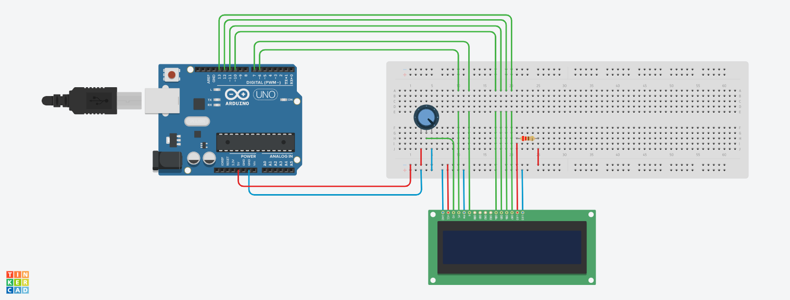

**Theory:**

1. Concept Used:
2. In Arduino, digital pins provide input as well as output but analog pins only provide input.
3. Potentiometer is used to control the contrast of LCD.
4. Four data buses are used to give signal to LCD from Arduino.
5. Data is first stored before passing to LCD.
6. Learning & Observations:
7. There is separate power supply for LCD backlight.
8. Learn about different parts of Arduino and how to use them.
9. How to use LCD with Arduino.
10. Initializing the library for using LCD.

**Problems and Troubleshooting:**

1. Display data on LCD which we write through keypad. It is solved by using different if- else conditions.
2. Data was not being displayed on LCD. It was solved by changing the settings of potentiometer.

**Precautions:**

1. Connections should be made carefully and clearly.
2. Centre wire of potentiometer should be connected to contrast pin of LCD.
3. Use right commands for serial monitor to store, show readings.
4. Using power to use backlight in LCD.
5. Register select, enable and data buses pins should be defined in series while initializing library.

**Learning Outcomes:**

1. Using Arduino and defining output pins.
2. Using different ports of LCD.
3. Using void setup and void loop.
4. Functions of different ports of LCD.

**Result:** Programmable Digital Data Display System was verified after uploading the program.